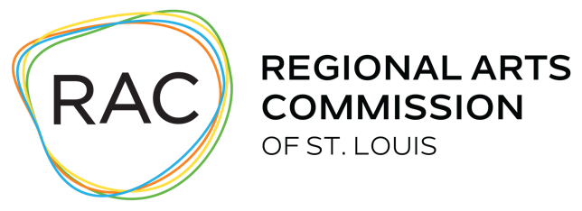
Organizational Health Worksheet
The following information is requested so that application reviewers and RAC staff can gain insight into your organization’s internal capacity to effectively advance your mission. The information will also be used to inform RAC’s planning of organizational professional development for the future.

- Does your board meet at least quarterly? Yes or No
If no, how often_________

- Are up-to-date financials presented and discussed at every meeting?
Yes or No

- What percentage of the board makes an annual cash contribution to the org?

- Does your board conduct a performance review of the executive director annually or every other year? Yes or No

- Is there a current strategic plan that is utilized? Yes or No
If yes, what are the start and end dates of the plan?
- Is your operating budget board-approved each year? Yes or No

- Regarding the current fiscal year, are you projecting a deficit? Yes or No
If yes, please address how your organization plans to cover the deficit. (maximum 200 words)

- Does your org have a cash reserve? Yes or No
If yes, does your organization have a board-approved policy regarding spending the reserve fund to finance cash shortfalls and/or program growth? Yes or No

- Does your organization have an endowment? Yes or No
If yes, has your organization been spending down its endowment assets? Yes or No
If yes, please explain (maximum 200 words)

- Please address your organization’s financial stability, including having a positive, unrestricted net asset balance or a plan to eliminate any deficit. Also provide an explanation for any year-to-year swing in either revenue or expenses or changes to endowment or cash reserve (current status, plans for acquiring or expanding), etc. (maximum 300 words)
- Organization metrics:
# subscribers/members in most recently completed FY ______
# donors in most recently completed FY ______
- Does your organization publish an annual report that includes a) the organization’s mission statement, b) a summary of the past year’s accomplishment, c) a roster of the officers and board members, and d) financial information that includes the total income in the past fiscal year and expenses in the same program, fundraising, and management categories as in the financial statements, and ending net assets? Yes or No
- Please address your organization’s ability to maintain operations and programs throughout 2024; feel free to elaborate on any of the questions posed. (optional) (maximum 500 words)

