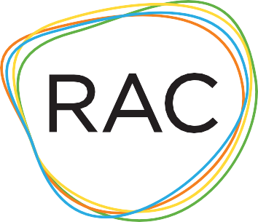

Organizational Health Worksheet
- What is the size of your board?

- How often does the board meet?

- What percentage of the board makes an annual cash contribution to the organization?

- Is your budget board-approved each year? YES or NO

- Does your board committee structure include an active ﬁnance committee? YES or NO

- Do you have a current strategic plan that is utilized? YES or NO 6a. If yes, what are the start and end dates of the plan?

- Does your organization engage an accountant/ﬁrm to conduct an annual audit? YES or NO

- Does your organization publish an annual report that includes
  - the organization’s mission statement
  - a summary of the past year’s accomplishment
  - a roster of the oﬃcers and board members, and
  - ﬁnancial information that includes the total income in the past ﬁscal year and expenses in the same program, fundraising, and administrative categories as in the ﬁnancial statements, and ending net assets? YES or NO

- Does your org have a reserve fund? YES or NO
6a. If yes, how many months of operating funds do you currently have?
Months

- Please address your organization’s ability to maintain operations and programs throughout the program year. Feel free to elaborate on any of the questions posed. (Optional)
(Maximum of 500 words)

